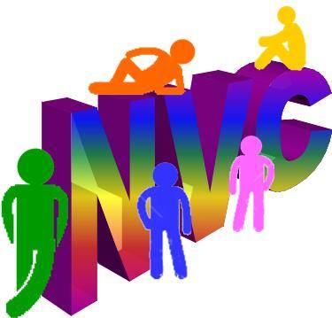

NVOT PTSO Ultimate Frisbee
Concussion Information

PARENT/ATHLETE CONCUSSION INFORMATION SHEET
A concussion is a type of traumatic brain injury that changes the way the brain normally works. It is caused by a bump, blow, or jolt to the head or body that causes the head and brain to move rapidly back and forth. Even a “ding,” “getting your bell rung,” or what seems to be a mild bump can be serious. Signs and symptoms of concussion can show up right after the injury or may not appear or be noticed until days or weeks after the injury. If an athlete reports one or more symptoms of concussion listed below after a bump, blow, or jolt to the head or body, s/he should be kept out of play the day of the injury and until a health care professional, experienced in evaluating for concussion, says s/he is symptom-free and it’s OK to return to play. Concussion Danger Signs: In rare cases, a dangerous blood clot may form on the brain in a person with a concussion and crowd the brain against the skull. An athlete should receive immediate medical attention if after a bump, blow, or jolt s/he exhibits any of the following danger signs: ●One pupil larger than the other ●Is drowsy or cannot be awakened ●A headache that not only does not diminish, but gets worse ●Weakness, numbness, or decreased coordination ●Repeated vomiting or nausea ●Loses consciousness (even if brief) ●Cannot recognize people or places ●Becomes increasingly confused, restless, or agitated ●Has unusual behavior ●Convulsions or seizures ●Slurred Speech
Why should an athlete report their symptoms? If an athlete has a concussion, his/her brain needs time to heal. While an athlete’s brain is still healing, s/he is much more likely to have another concussion. Repeat concussions can increase the time it takes to recover. In rare cases, repeat concussions in young athletes can result in brain swelling or permanent damage to their brain. They can even be fatal.
What should you do if you think your athlete has a concussion? If you suspect that an athlete has a concussion, remove the athlete from play and seek medical attention. Do not try to judge the severity of the injury yourself. Keep the athlete out of play the day of the injury and until a health care professional, experienced in evaluating for concussion, says s/he is symptom-free and it’s OK to return to play.
Rest is key to helping an athlete recover from a concussion. Exercising or activities that involve a lot of concentration, such as studying, working on the computer, or playing video games, may cause concussion symptoms to reappear or get worse. After a concussion, returning to sports and school is a gradual process that should be carefully managed and monitored by a health care professional. It’s better to miss one game than the whole season. For more information on concussions, visit: www.cdc.gov/Concussion and cdc.gov/concussion/headsup/pdf/Parent_Athlete_info_sheet-a.pdf

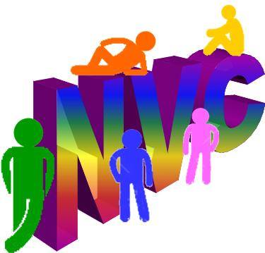

NVOT PTSO ULTIMATE FRISBEE
WAIVER AND RELEASE OF LIABILITY

This waiver may not be modified. Signed waivers are required to participate in NVOT PTSO Ultimate Frisbee events. In consideration of being allowed to participate in any way in NVOT PTSO Ultimate Frisbee programs, related events & activities, the undersigned acknowledges, appreciates & willingly agrees that:
1. I will comply with the stated & customary terms & conditions for participation. If, however, I observe any unusual significant hazard during my presence or participation, I will remove myself from participation & bring such to the attention of the nearest official immediately. 2. I acknowledge & fully understand that each participant will be engaging in activities that involve risk of serious injury including traumatic brain injury, permanent disability & death, & severe social & economic losses which may result not only from their own actions, inactions or negligence but the action, inaction or negligence of others, the rules of play, or the condition of the premises or of any equipment used. Further, I accept personal responsibility for the damages following such injury including traumatic brain injury, permanent disability or death. 3. I knowingly & freely assume all such risk, both known & unknown, even those arising from the negligent acts or omissions of others & assume full responsibility for my participation. 4. I, for myself & on behalf of my heirs, assigns, personal representatives & next of kin, hereby release, & agree to hold harmless NVOT PTSO Ultimate Frisbee, its officers, officials, affiliated clubs, their respective administrators, directors, agents, coaches, & other employees of the organization, other participants, sponsoring agencies, advertisers, &, if applicable owners & lessors of premises used to conduct the event, all of which are hereinafter referred to as “releasees”, with respect to all & any injury, disability, death or loss or damage to person or property, whether arising from the negligence of the releasees or otherwise, to the fullest extent permitted by law. I will indemnify, save & hold harmless above named releasees of, from & against any loss, cost, expense, damage or liability that such releasees may incur as a result of, arising from or in connection with such claim, including without limitation any attorney's fees, or other costs or expenses or litigation. 6. I agree that, as a NVOT PTSO Ultimate Frisbee member, player, organizer or representative of the organization, I will not compete at NVOT PTSO Ultimate Frisbee events, or carry out responsibilities related to official organization & event business, while under the influence of alcohol or illegal/banned drugs. Additionally, I will not engage in any unlawful acts at such events, including but not limited to the unlawful or unauthorized use, possession, distribution or consumption of alcoholic beverages or illegal/banned drugs at said events. 7. I will comply with and be bound by the stated and customary terms and conditions for participation. If, however, I observe any unusual significant hazard during my presence or participation, I will remove myself from participation and bring such to the attention of the nearest official immediately.
I have read this release of liability and assumption of risk agreement, fully understand its terms, and understand that I have given up substantial rights by signing it and sign it freely and voluntarily without any inducement. Additionally, I acknowledge receipt of the concussion information also found at cdc.gov/concussion/headsup/pdf/Parent_Athlete_info_sheet-a.pdf.
Participant is 18 or Older Date: __________________ Participant’s Signature (under 18 do not need to sign): _______________________________________________
This is to certify that I, as parent/guardian with legal responsibility for this participant, do consent and agree to indemnify and hold harmless the releasees from any and all liabilities incident to my minor child’s involvement or participation in these programs above, even if arising from their negligence, to the fullest extent permitted by law.
Participant is Under 18 Years Date: __________________ Parent/Guardian Signature (required if participant is under 18):_________________________________________

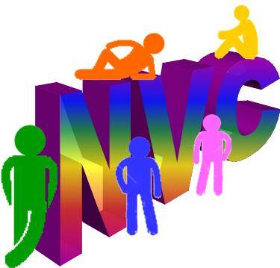

NVOT PTSO Ultimate Frisbee
Medical Authorization Form

Purpose: To enable parents or guardians to authorize the provision of emergency treatment for their
children who are injured or become ill while under the authority of [Name of chaperone] _________________
______________________________________ in the event the parents or guardians cannot be reached.
This acknowledges that we, the undersigned, parent(s) or legal guardian(s) of [Name of participant] _______
______________________________________ recognize the potentially hazardous nature of the sport of
Frisbee that an injury might be sustained. These injuries include but are not limited to PERMANENT
DISABILITY, BLINDNESS, PARALYSIS AND DEATH. In the event of such an injury to my child and we (I
or my spouse or guardian) cannot be contacted, we give permission to qualified and licensed EMTs,
physicians, paramedics, certified athletic trainers, and/or other medical or hospital personnel to render
such treatment.
We (I) release NVOT PTSO and its volunteers and its assigns from any personal
injuries caused by or having any relation to this activity. We (I) understand that this release applies to any
present or future injuries or illnesses and that it binds my heirs, executors and administrators.
This release form is completed and signed of my own free will and with full knowledge of its significance.
I have read and understand all of its terms.
Parent/Guardian:
____________________________________________________________________________________
Name Printed Signature Date Phone
Parent/Guardian:
____________________________________________________________________________________
Name Printed Signature Date Phone
Family Physician:
____________________________________________________________________________________
Name Printed Address Phone
Preferred Hospital: ________________________________________________________
Child’s Medical Insurance Carrier: ______________________________________________________
Name Phone
Emergency Contact:
____________________________________________________________________________________
Name Printed Address Phone
Specific facts concerning child’s medical history including allergies, medications being taken, chronic
illness or other conditions which a physician should be alerted to:________________________________
_____________________________________________________________________________

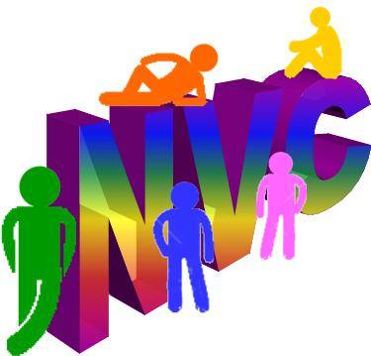

Acknowledgements

Your signature below acknowledges the following:

- Only scheduled practices and games with adult supervision arranged for through Northern Valley Coalition are considered part of this program.
- Pick up games of Frisbee are not part of this program.
- All practices and games must have adult supervision arranged for through Northern Valley Coalition.
- In order to have rec opportunity for Frisbee, parents must be willing to supervise 1 Sunday afternoon practice in the season. If a parent scheduled to supervise cannot make it, it is the parent’s responsibility to arrange for another adult or notify that the practice will have to be cancelled.

I have read the above acknowledgements and agree to abide by them:

Parent signature: _______________________________________
Parent email: ___________________________________________
Date: ____________________________________________________

